
RAMAIAH
INSTITUTE OF TECHNOLOGY
USN | 1 | M | S

(Autonomous Institute, Affiliated to VTU)
Bangalore – 560 054

SEMESTER END EXAMINATIONS – MAY/JUNE 2017

Course & Branch | : | B.E: Electrical & Electronics Engineering | Semester | : | VI
Subject | : | Power Systems - I | Max. Marks | : | 100
Subject Code | : | EE601 | Duration | : | 3 Hrs

Instructions to the Candidates:
- Answer one full question from each unit.

 |  | UNIT-I
1. | a) | Discuss three major advantages of per unit system in detail. | CO2 | (06)
 | b) | Explain the structure of a typical power system. Also explain the concept of active and reactive power and their flow in a power system. | CO1 | (06)
 | c) | A generator connected through a circuit breaker to a transformer is rated 100MVA, 18kV, with reactances of Xd”= 19% and Xd= 130%. It is operating on no load and rated voltage when a three phase short circuit occurs between the breaker and the transformer. Find a)the steady state short circuit current in the breaker b) the initial sub-transient current in the breaker and c) the maximum possible dc component of the short circuit current in the breaker. | CO3 | (08)
2. | a) | Show that the pu impedance of a transformer is same whether it is referred to its LV side or HV side. | CO2 | (06)
 | b) | Explain the concept of complex power and the direction of power flow. | CO1 | (06)
 | c) | A synchronous generator and motor as shown in fig. 2(c) are rated for 30MVA, 13.2kV and both have sub-transient reactance of 20%. The line connecting them has a reactance of 10% on the base of machine ratings. The motor is drawing 20MW at 0.8 leading power factor. The terminal voltage of the motor is 12.8kV. If a symmetrical fault occurs at the motor terminals, find the sub-transient fault current.  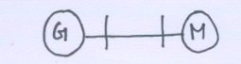  Fig. 2(c) | CO3 | (08)
 |  | UNIT- II
3. | a) | The voltages at the terminals of a balanced load consisting of three 10Ω resistors connected in star are V_{ab} =100∟0⁰, V_{bc}=80.8∟-121.44⁰, V_{ca}=90∟130⁰ all in volts. Assuming that there is no connection to the neutral of the load find the line currents from the symmetrical components of the given line voltages. Also find the power expended in the 10Ω resistors from the symmetrical components of currents and voltages. Phase sequence is abc. | CO4 | (12)
 | b) | Show that a balanced three phase system of voltage phasor contains only positive sequence components. | CO4 | (08)
4. | a) | When a generator has terminal ‘a’ open and other two terminals are connected to each other with a short circuit from this connection to ground, typical values for the symmetrical components of current in the phase a are I_{a1}=600∟-90⁰A, I_{a2}=250∟90⁰A, I_{a0}=350∟90⁰A. Calculate the current in each phase of the generator and the current in the neutral conductor. | CO4 | (08)
 | b) | Discuss the phase shifts of sequence components of voltages in the primary and secondary windings of a star-delta transformer with the help of phasor diagrams. Also explain the relevance of vector groups in transformers. | CO4 | (12)
 |  | UNIT-III
5. | a) | Across a star connected symmetrical impedance load of 10Ω in each phase and a neutral impedance of 3.33 Ω, an unbalanced three phase supply with $V_{a} =\text{220} [0^{0} , V_{b} = \text{200} [{\text{110}}^{0} \text{and} V_{c} = \text{180}[−{\text{110}}^{o}$ is applied. Determine the line currents using symmetrical components. | CO4 | (12)
 | b) | Prove that a three-phase symmetrically wound alternator generates only positive sequence components of voltages. | CO4 | (08)
6. | a) | Write sequence networks of the following:  - synchronous generator  - three-phase transformers (Δ-Δ&Υ-Υ(grounded)) | CO4 | (08)
 | b) | The one-line diagram of a power system is shown in Fig. 6(b). The ratings of the devices are as follows:  G1 & G2: 104 MVA, 11.8kV, x₁ = x₂ = 0.2 pu, x_{o} = 0.1 pu  T1 & T2: 125 MVA, 11 Y- 220 Y kV, x₁=x₂ = x_{o} = 0.1 pu  T3 & T4: 120MVA, 230 Y – 6.9 YKV, x₁ = x₂ = x_{o} = 0.12 pu  M1 = 175 MVA, 6.6 kV, x₁ = x₂ = 0.3 pu x_{o} = 0.15 pu  M2 = 50 MVA, 6.9 kV, x₁ = x₂ = 0.3 pu x_{o} = 0.1 pu  Transmission line reactances: x₁ = x₂ = 30 ohm x_{o} = 60 ohm  Draw the sequence impedance diagram in pu on a base of 200 MVA, 220kV in the transmission lines. Also, find the equivalent positive sequence impedance as seen from the midpoint of line – B.  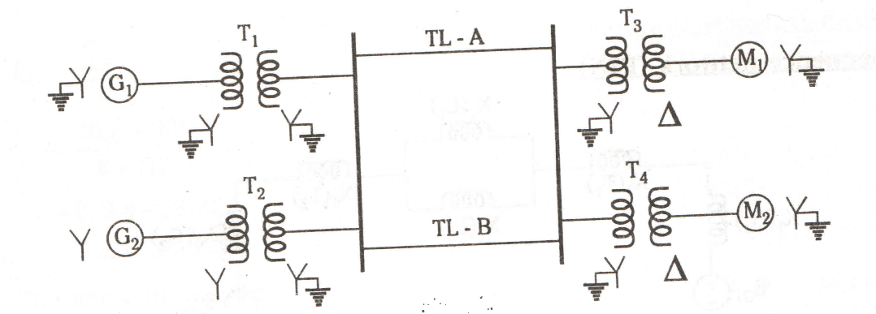  Fig. 6(b) | CO4 | (12)
 |  | UNIT-IV
7. | a) | A salient pole generator is rated 20MVA, 13.8kV, with X₁= 0.25pu, X₂= 0.35pu and X₀=0.1pu. The neutral of the generator is solidly grounded. Determine the sub-transient current in the generator and the line to line voltages for sub-transient condition when an L-G fault occurs at the generator terminal with the generator operating at rated voltage. Neglect resistance. | CO4 | (12)
 | b) | The reactances of a generator rated 100MVA, 20kV, are X_{d}”=X₁=X₂=20% and X₀=5%. The generator is connected to a Δ-Y transformer rated 100MVA, 20Δ-230Y kV, with a reactance of 10%. The neutral of the transformer is solidly grounded. The terminal voltage of the generator is 20kV when a single line-to-ground fault occurs on the open circuited, high voltage side of the transformer. Find the initial symmetrical rms current in all phases of the generator. | CO4 | (08)
8. | a) | A 25 MVA, 3phase generator has a sub-transient reactance of 20%. The generator supplies 2 motors over a transmission line with transformer at both ends as shown in Fig.8(a). The motors have rated input of 15 and 7.5 MVA, both 10kV with 25% sub-transient reactances. Both the 3 phase transformers are rated 30MVA, 10.8/121kV, connection, Δ-Y, with leakage reactance of 10% each. The series reactance of line is 100Ω. Calculate the fault current when a single line to ground fault occurs at F on the line. The motors are loaded to draw 15 and 7.5MW at 10kV and 0.8pf leading. Assume that negative sequence reactance is equal to positive sequence reactance. The zero sequence reactance is shown in the figure.  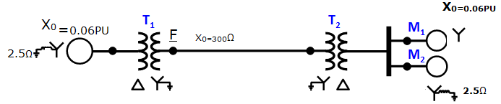  Fig.8(a) | CO4 | (15)
 | b) | Briefly explain about unsymmetrical faults in a power system. | CO4 | (05)
 |  | UNIT- V
9. | a) | Discuss the methods of improving transient stability. | CO5 | (06)
 | b) | Explain critical clearing angle and critical clearing time. | CO5 | (06)
 | c) | A 200MVA, 11kV, 50Hz, 4 pole turbo generator has an inertia constant of 6MJ/MVA.  i) Find the stored energy in the rotor at synchronous speed.  ii) The machine is operating at a load of 120MW when the load suddenly increases to 160MW. Find the rotor retardation. Neglect losses  iii) The retardation calculated above is maintained for 5 cycles. Find the change in power angle and rotor speed at the end of this period. | CO5 | (08)
10. | a) | A 60-Hz generator is supplying 60%of P_{max} to an infinite bus through a reactive network. A fault occurs which increases the reactance of the network between the generator terminal voltage and the infinite bus by 400%. When the fault is cleared the maximum power that can be delivered is 80% of the original maximum value. Determine the critical clearing angle for the condition described. | CO5 | (08)
 | b) | Write short notes on i)power system stability ii) SSSL and TSL iii) equal area criterion. | CO5 | (12)
****************

